2023-08-02

HOËRSKOOL ZWARTKOP

|  |  |
| --- | --- |
| A picture of a winding road and trees  IT Gr10 – PAT 2023 | AbstRAK  My PAT sal handel oor 'n Entrepreneurs-bestuurstelsel wat ek in die middae tuis, na skool, bedryf. Ek het besluit om my kennis van IT aan te wend om so 'n bestuurstelsel, in die vorm van 'n Delphi-program, vir my Snoepie-projek te skryf.  NAAM  Johan Joubert IT10XX |

1. TAAK 1A – TAAKDEFINISIE 1

1.1 Onderwerp 1

1.2 Probleem 1

1.3 Moontlike Oplossing 1

1.4 Reikwydte / Beperkings 1

2. TAAK 1B - GEBRUIKERSTORIES 2

3. TAAK 2 – AANVAARDINGSTOETSE 2

4. TAAK 3 – NAVIGASIE EN VLOEIDIAGRAMME 2

5. TAAK 4A – GUI / SKERMONTWERP 3

6. TAAK 4B – DATA-WOORDEBOEK 3

7.1 TEKSLÊERS 3

7.2 SKIKKING 3

7. TAAK 5 – TVA-TABELLE EN TOE-CHARTS 0

BYLAAG B 0

BYLAAG C 1

# TAAK 1A – TAAKDEFINISIE

## Onderwerp

Ek gaan 'n PAT Taak doen wat vir my Entrepreneurs-projek nl. 'n Snoepwinkel gebruik gaan word.

## Probleem

Daar word van my as Gr10 IT-leerder verwag om 'n Delphi-program te skryf waarin ek al die kennis wat ek deur die loop van die jaar opgedoen het, sal demonstreer om die Delphi-program te skryf. Die projek moet gaan oor 'n Entrepreneurs-projek.

## Moontlike Oplossing

Ek sal die projek in 2 fases aanpak nl. Fase 1, wat take 1 -5 bevat en Fase 2, wat take 6 – 10 bevat. Ek sal poog om alle beginsels wat ek in Gr10 geleer het toe te pas bv. benoeming van veranderlikes en komponente met die korrekte benamings-konvensies. Verder sal ek gebruikerstories in die vorm van 'n tabel-vorm aanbied. sal ook van TOE-charts, TVA-tabelle, GUI's skep in die beplanning van my Delphi-projek. Ek sal ook poog om programmeringsstrukture soos Case-stelling, Geneste If Then Else-stellings, Lusse, ens. in my PAT-projek te gebruik. My Delphi-projek sal van 1 dimensionele skikkings gebruik maak om data in te stoor. Verder sal ek van tekslêers gebruik maak, wat volgens die dag se datum benoem sal word, om my daaglikse verkope in te stoor en so rekord te hou van my verkope.

## Reikwydte / Beperkings

Geen verkope op skuld sal aan enige persoon toegestaan word nie want dit plaas 'n verdere las op my as Entrepreneur om later weer daardie gelde te moet probeer insamel nie. Dus as 'n persoon nie die nodige fondse het nie, sal hy/sy die produkte moet verminder of die transaksie kanselleer totdat hy/sy oor genoeg fondse beskik.

# TAAK 1B - GEBRUIKERSTORIES

and text box designs that complement each other. For example, you can add a matching cover page, header, and sidebar. Click Insert and then choose the elements you want from the different galleries. Themes and styles also help keep your document coordinated. When you click Design and choose a new Theme, the pictures, charts, and SmartArt graphics change to match your new theme. When you apply styles, your headings change to match the new theme.

Save time in Word with new buttons that show up where you need them. To change the way a

|  |  |  |  |  |  |
| --- | --- | --- | --- | --- | --- |
| **GDGDGDG** | | | | | |
|  |  |  |  |  |  |
|  | |  |  |  |  |

picture fits in your document, click it and a button for layout options appears next to it. When you work on a table, click where you want to add a row or a column, and then click the plus sign. Reading

# TAAK 2 – AANVAARDINGSTOETSE

is easier, too, in the new Reading view. You can collapse parts of the document and focus on the text you want. If you need to stop reading before you reach the end, Word remembers where you left off - even on another device.

Video provides a powerful way to help you prove your point. When you click Online Video, you can paste in the embed code for the video you want to add. You can also type a keyword to search online for the video that best fits your document. To make your document look professionally produced, Word provides header, footer, cover page, and text box designs that complement each

# TAAK 3 – NAVIGASIE EN VLOEIDIAGRAMME

other. For example, you can add a matching cover page, header, and sidebar. Click Insert and then choose the elements you want from the different galleries.

Themes and styles also help keep your document coordinated. When you click Design and choose a new Theme, the pictures, charts, and SmartArt graphics change to match your new theme. When you apply styles, your headings change to match the new theme. Save time in Word with new buttons that show up where you need them. To change the way a picture fits in your document, click it and a button for layout options appears next to it. When you work on a table, click where you want to add a row or a column, and then click the plus sign.

# TAAK 4A – GUI / SKERMONTWERP

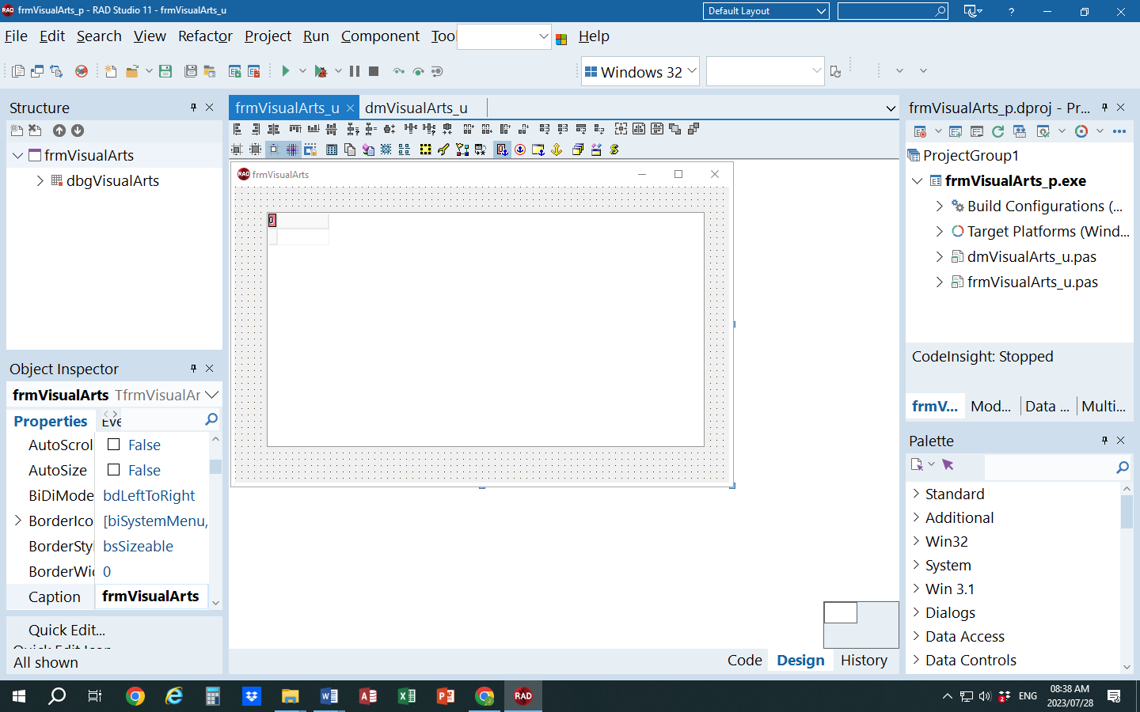

DBGrid om Databasis-tabel te vertoon

btnVerwerk

# TAAK 4B – DATA-WOORDEBOEK

## 7.1 TEKSLÊERS

Beskryf hoe hoe jy die tekslêer gaan gebruik.

## 7.2 SKIKKING

Beskryf hoe hoe jy die skikking gaan gebruik.

- even on another device.

# TAAK 5 – TVA-TABELLE EN TOE-CHARTS

Video provides a powerful way to help you prove your point. When you click Online Video, you can paste in the embed code for the video you want to add. You can also type a keyword to search online for the video that best fits your document. To make your document look professionally produced, Word provides header, footer, cover page, and text box designs that complement each other. For example, you can add a matching cover page, header, and sidebar. Click Insert and then choose the elements you want from the different galleries.

Themes and styles also help keep your document coordinated. When you click Design and choose a new Theme, the pictures, charts, and SmartArt graphics change to match your new theme. When you apply styles, your headings change to match the new theme. Save time in Word with new buttons that show up where you need them. To change the way a picture fits in your document, click it and a button for layout options appears next to it. When you work on a table, click where you want to add a row or a column, and then click the plus sign.

Reading is easier, too, in the new Reading view. You can collapse parts of the document and focus on the text you want. If you need to stop reading before you reach the end, Word remembers where you left off - even on another device. Video provides a powerful way to help you prove your point.

# BYLAAG B

Leerderverklaring – Fase ____

Ek verstaan dat werk wat ek vir assessering inlewer, my eie werk moet wees. Het jy hulp/inligting van enigeen ontvang om hierdie werk te lewer?

Nee Ja (verskaf besonderhede hieronder)

|  |  |
| --- | --- |
| Hulp/Inligting  ontvang van (persoon): | Aard van die hulp/inligting (verskaf bewyse): |
|  |  |
| / / 2023  HANDTEKENING VAN LEERDER DATUM | |

# BYLAAG C

Verklaring van egtheid

|  |  |  |  |
| --- | --- | --- | --- |
| **Leerder se naam** |  | **ID-nommer** |  |
| **Graad** | 12 | **Jaar** | 2023 |
| **Vak** | INLIGTINGSTEGNOLOGIE | | |
| Praktiese Assesseringstaak (PAT) | | **Onderwyser** |  |
| Ek verklaar hiermee dat die inhoud van hierdie assesseringstaak my eie, oorspronklike werk is (behalwe waar daar duidelike erkenning en toepaslike verwysing na die werk van ander gegee word) en dat dit nie deur plagiaat bekom is, van iemand anders gekopieer is of voorheen vir assessering deur enigeen ingedien is nie. | | | |
| / / 2023  HANDTEKENING VAN LEERDER DATUM | | | |